**UTS WEB PROGRAMING**

**Nama :Eko Satrio**

**NIM : STI202303622**

1. **Index.Html**

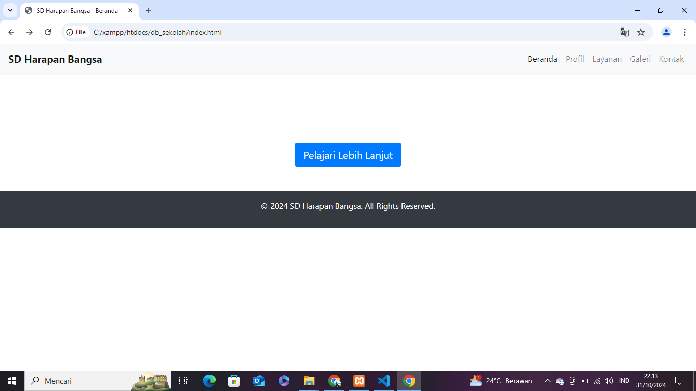

**Index.html**

<!DOCTYPE html>

<html lang="en">

<head>

<meta charset="UTF-8">

<meta name="viewport" content="width=device-width, initial-scale=1.0">

<title>SD Harapan Bangsa - Beranda</title>

<link rel="stylesheet" href="https://stackpath.bootstrapcdn.com/bootstrap/4.5.2/css/bootstrap.min.css">

<link rel="stylesheet" href="assets/css/style.css">

</head>

<body>

<!-- Navbar -->

<nav class="navbar navbar-expand-lg navbar-light bg-light shadow-sm">

<a class="navbar-brand font-weight-bold" href="index.html">SD Harapan Bangsa</a>

<button class="navbar-toggler" type="button" data-toggle="collapse" data-target="#navbarNav" aria-controls="navbarNav" aria-expanded="false" aria-label="Toggle navigation">

<span class="navbar-toggler-icon"></span>

</button>

<div class="collapse navbar-collapse" id="navbarNav">

<ul class="navbar-nav ml-auto">

<li class="nav-item active"><a class="nav-link" href="index.html">Beranda</a></li>

<li class="nav-item"><a class="nav-link" href="profil.html">Profil</a></li>

<li class="nav-item"><a class="nav-link" href="layanan.html">Layanan</a></li>

<li class="nav-item"><a class="nav-link" href="galeri.html">Galeri</a></li>

<li class="nav-item"><a class="nav-link" href="kontak.html">Kontak</a></li>

</ul>

</div>

</nav>

<!-- Hero Section -->

<header class="hero-section text-white d-flex align-items-center justify-content-center">

<div class="text-center">

<h1 class="display-4 font-weight-bold">Selamat Datang di SD Harapan Bangsa</h1>

<p class="lead">Menginspirasi dan mendidik generasi penerus bangsa.</p>

<a href="profil.html" class="btn btn-primary btn-lg mt-3">Pelajari Lebih Lanjut</a>

</div>

</header>

<!-- Footer -->

<footer class="footer bg-dark text-white text-center p-3 mt-5">

<p>&copy; 2024 SD Harapan Bangsa. All Rights Reserved.</p>

</footer>

<!-- Script -->

<script src="https://code.jquery.com/jquery-3.5.1.slim.min.js"></script>

<script src="https://cdn.jsdelivr.net/npm/@popperjs/core@2.0.6/dist/umd/popper.min.js"></script>

<script src="https://stackpath.bootstrapcdn.com/bootstrap/4.5.2/js/bootstrap.min.js"></script>

</body>

</html>

1. **Layanan.Html**

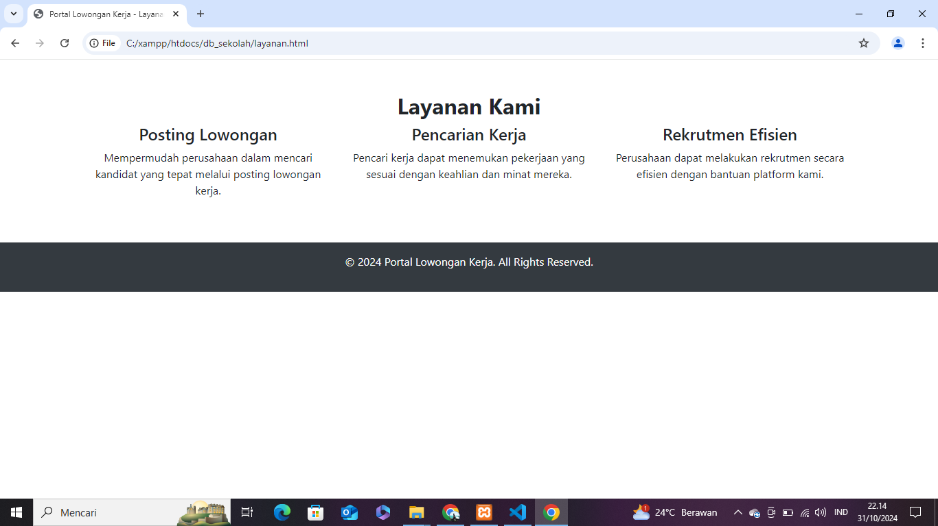

<!DOCTYPE html>

<html lang="id">

<head>

<meta charset="UTF-8">

<meta name="viewport" content="width=device-width, initial-scale=1.0">

<title>Portal Lowongan Kerja - Layanan</title>

<link rel="stylesheet" href="https://stackpath.bootstrapcdn.com/bootstrap/4.5.2/css/bootstrap.min.css">

<link rel="stylesheet" href="assets/css/style.css">

</head>

<body>

<!-- Navbar -->

<!-- Salin Navbar dari `index.html` -->

<!-- Layanan Section -->

<div class="container mt-5">

<h2 class="text-center font-weight-bold">Layanan Kami</h2>

<div class="row">

<div class="col-md-4 text-center">

<h4>Posting Lowongan</h4>

<p>Mempermudah perusahaan dalam mencari kandidat yang tepat melalui posting lowongan kerja.</p>

</div>

<div class="col-md-4 text-center">

<h4>Pencarian Kerja</h4>

<p>Pencari kerja dapat menemukan pekerjaan yang sesuai dengan keahlian dan minat mereka.</p>

</div>

<div class="col-md-4 text-center">

<h4>Rekrutmen Efisien</h4>

<p>Perusahaan dapat melakukan rekrutmen secara efisien dengan bantuan platform kami.</p>

</div>

</div>

</div>

<!-- Footer -->

<footer class="footer bg-dark text-white text-center p-3 mt-5">

<p>&copy; 2024 Portal Lowongan Kerja. All Rights Reserved.</p>

</footer>

</body>

</html>

1. **galeri.Html**

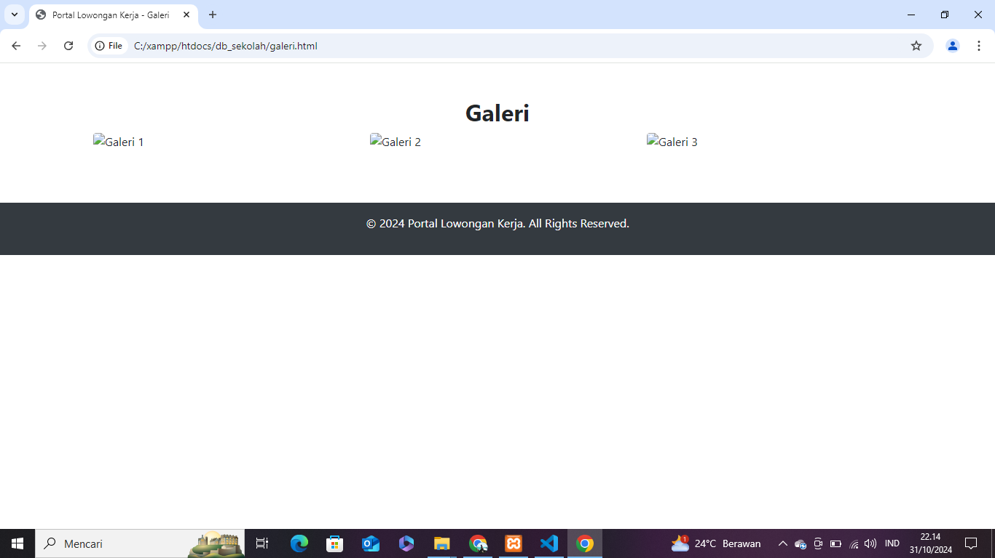

**<!DOCTYPE html>**

**<html lang="id">**

**<head>**

**<meta charset="UTF-8">**

**<meta name="viewport" content="width=device-width, initial-scale=1.0">**

**<title>Portal Lowongan Kerja - Galeri</title>**

**<link rel="stylesheet" href="https://stackpath.bootstrapcdn.com/bootstrap/4.5.2/css/bootstrap.min.css">**

**<link rel="stylesheet" href="assets/css/style.css">**

**</head>**

**<body>**

**<!-- Navbar -->**

**<!-- Salin Navbar dari `index.html` -->**

**<!-- Galeri Section -->**

**<div class="container mt-5">**

**<h2 class="text-center font-weight-bold">Galeri</h2>**

**<div class="row">**

**<div class="col-md-4 mb-4">**

**<img src="assets/img/galeri1.jpg" class="img-fluid rounded" alt="Galeri 1">**

**</div>**

**<div class="col-md-4 mb-4">**

**<img src="assets/img/galeri2.jpg" class="img-fluid rounded" alt="Galeri 2">**

**</div>**

**<div class="col-md-4 mb-4">**

**<img src="assets/img/galeri3.jpg" class="img-fluid rounded" alt="Galeri 3">**

**</div>**

**</div>**

**</div>**

**<!-- Footer -->**

**<footer class="footer bg-dark text-white text-center p-3 mt-5">**

**<p>&copy; 2024 Portal Lowongan Kerja. All Rights Reserved.</p>**

**</footer>**

**</body>**

**</html>**

1. **profil.Html**

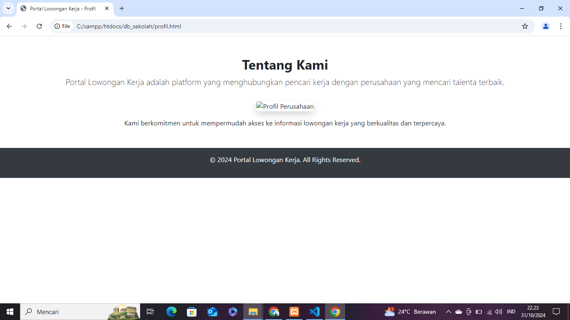

**<!DOCTYPE html>**

**<html lang="id">**

**<head>**

**<meta charset="UTF-8">**

**<meta name="viewport" content="width=device-width, initial-scale=1.0">**

**<title>Portal Lowongan Kerja - Profil</title>**

**<link rel="stylesheet" href="https://stackpath.bootstrapcdn.com/bootstrap/4.5.2/css/bootstrap.min.css">**

**<link rel="stylesheet" href="assets/css/style.css">**

**</head>**

**<body>**

**<!-- Navbar -->**

**<!-- Salin Navbar dari `index.html` -->**

**<!-- Profil Section -->**

**<div class="container mt-5">**

**<div class="text-center">**

**<h2 class="font-weight-bold">Tentang Kami</h2>**

**<p class="lead">Portal Lowongan Kerja adalah platform yang menghubungkan pencari kerja dengan perusahaan yang mencari talenta terbaik.</p>**

**<img src="assets/img/profil-perusahaan.jpg" class="img-fluid rounded shadow mt-3" alt="Profil Perusahaan" style="max-width: 400px;">**

**<p class="mt-3">Kami berkomitmen untuk mempermudah akses ke informasi lowongan kerja yang berkualitas dan terpercaya.</p>**

**</div>**

**</div>**

**<!-- Footer -->**

**<footer class="footer bg-dark text-white text-center p-3 mt-5">**

**<p>&copy; 2024 Portal Lowongan Kerja. All Rights Reserved.</p>**

**</footer>**

**</body>**

**</html>**

1. **kontak.html**

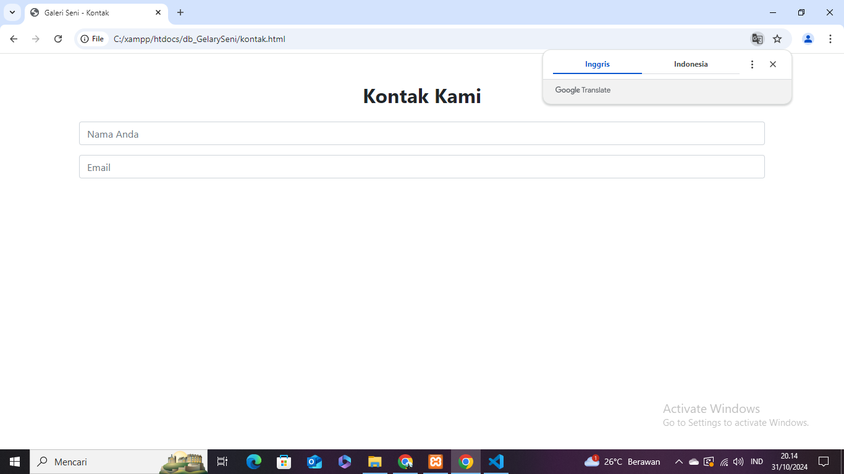

**<!DOCTYPE html>**

**<html lang="en">**

**<head>**

**<meta charset="UTF-8">**

**<meta name="viewport" content="width=device-width, initial-scale=1.0">**

**<title>Galeri Seni - Kontak</title>**

**<link rel="stylesheet" href="https://stackpath.bootstrapcdn.com/bootstrap/4.5.2/css/bootstrap.min.css">**

**<link rel="stylesheet" href="assets/css/style.css">**

**</head>**

**<body>**

**<!-- Navbar -->**

**<!-- Salin Navbar dari `index.html` -->**

**<!-- Kontak Section -->**

**<div class="container mt-5">**

**<h2 class="text-center font-weight-bold">Kontak Kami</h2>**

**<form class="text-center mt-4">**

**<div class="form-group">**

**<input type="text" class="form-control" placeholder="Nama Anda">**

**</div>**

**<div class="form-group">**

**<input type="email" class="form-control" placeholder="Email">**

**</div>**

**<div class**